Chapter 5, Problem 58

Calculate i_{o} in the op amp circuit of Fig. 5.85.

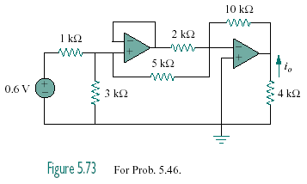
Figure 5.85
For Prob. 5.58.

